**Media Literacy Matters – Western Balkans**

Based on the goals of the second and final segment of the project ***„Building capacity for media literacy for students of the Western Balkans in the fight against the spread of disinformation“***, we (Petra Boškova's group) planned and implemented a campaign called ***„Media literacy is important - Western Balkans“***.

**INSTAGRAM PROFILE:** [**https://www.instagram.com/media.literacy.wb/**](https://www.instagram.com/media.literacy.wb/)

**Structure of campaign**

* Themes: 1) Fundamentals of media literacy; 2) Building media literacy; 3) Relationship between media literacy and social networks; 4) “Targets“ (mis/disinformation) of media literacy; 5) „Three step“ process of recognition of mis/disinformation; 6) Consequences of mis/disinformation; 7) Self-protection from mis/disinformation; 8) Fact-checking; 9) Fact-checking tools; 10) Verification of images and videos; 11) Importance of fact checking for society; 12) Fundamentals of OSINT.
* Target group: people aged 16 to 22.
* Target number: 50.
* Platform: Instagram account.
* Instruments: ChatGPT 4.0, Canva, Pixlr, Freepik, Microsoft ClipChamp, Google Forms.

**Survey** (special and last step of the campaign)

* Type: online.
* Questions: closed.
* Number of respondents: 50.
* Purpose: insight into the level of knowledge gained through the campaign.
* Results:

On the question „What is media literacy in practice? “, 49 respondents answered correctly and 1 respondent answered incorrectly.

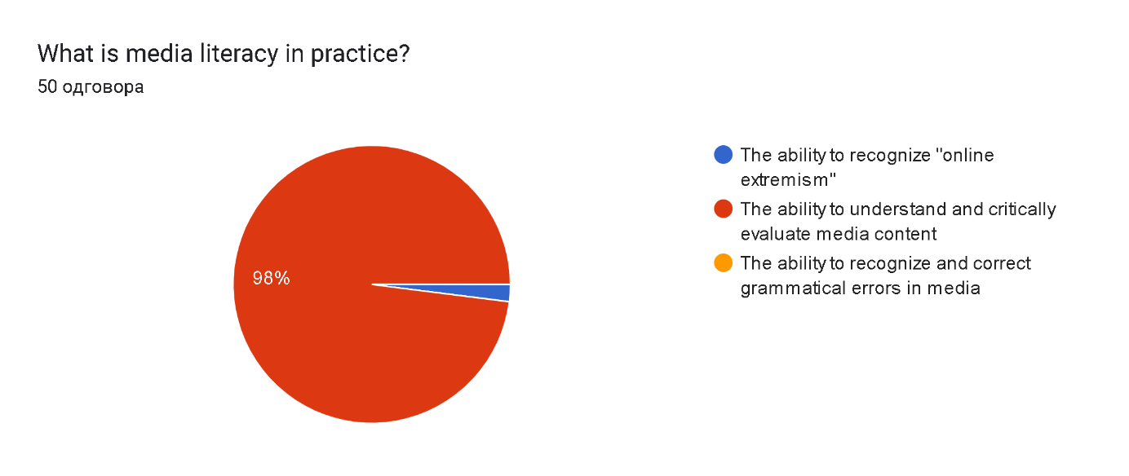

50 respondents answered correctly the question, „What are the “targets“ of media literacy?“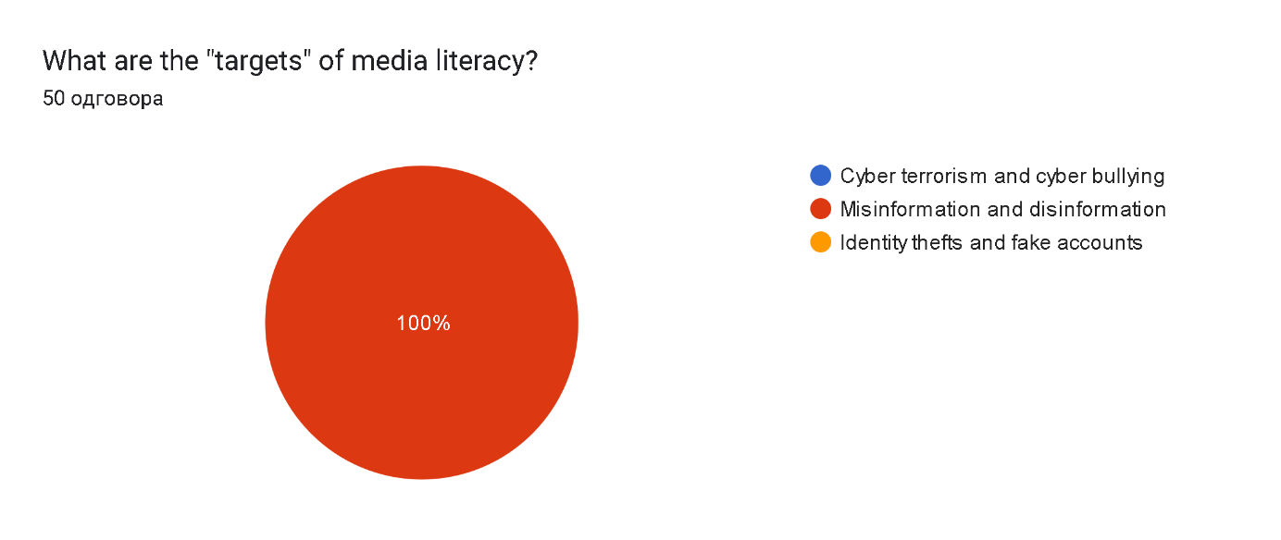

On the question „Which of these is correct?“, 28 respondents answered correctly and 22 respondents answered incorrectly.

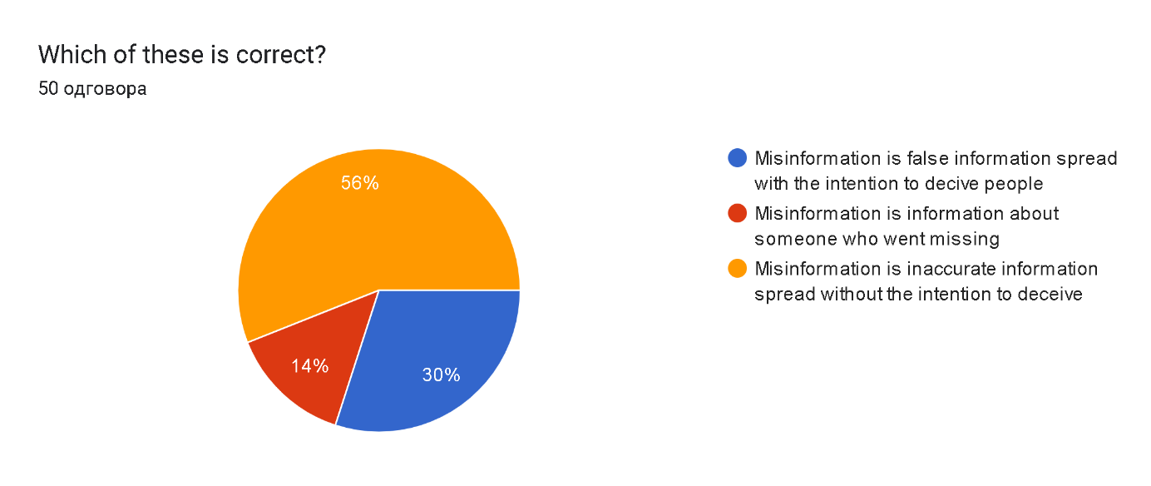

On the question „Is this correct? – ‘The main difference between disinformation and misinformation is intention.’“, 48 respondents answered correctly and 2 respondents answered incorrectly.

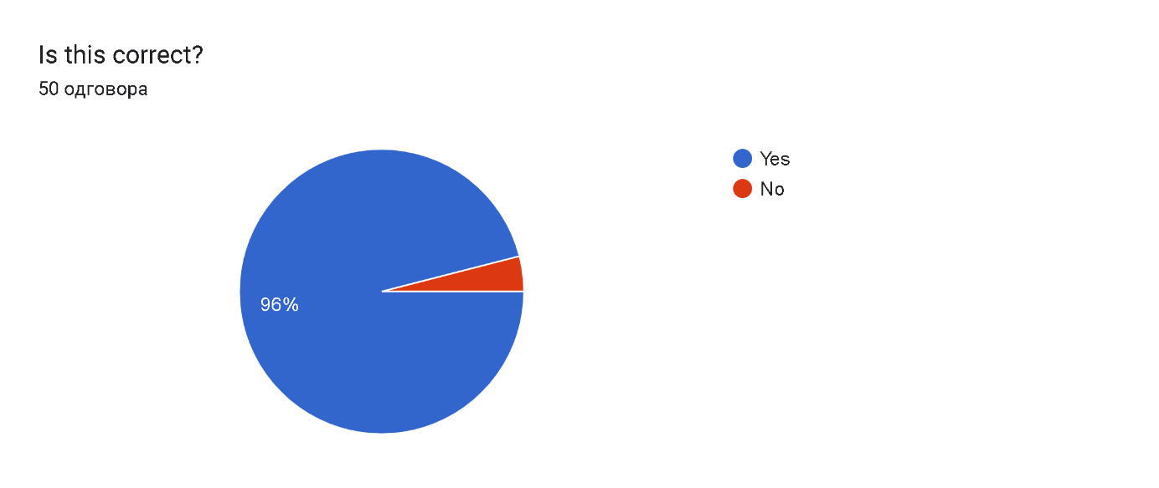

On the question, „Is this correct? ‘The main difference between disinformation and misinformation is intention.’“50 respondents answered correctly.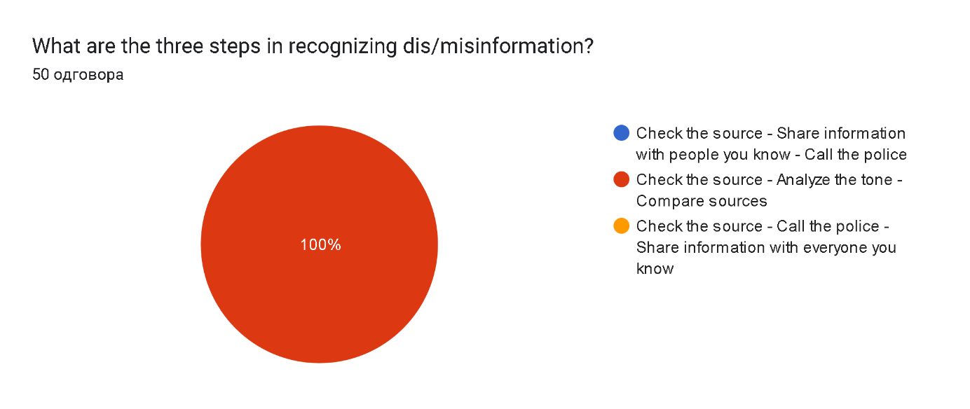

On the question „Is this correct? – ‘Potential objects of dis/misinformation influence are society, politics, health and safety“, 49 respondents answered correctly and 1 respondent answered incorrectly.

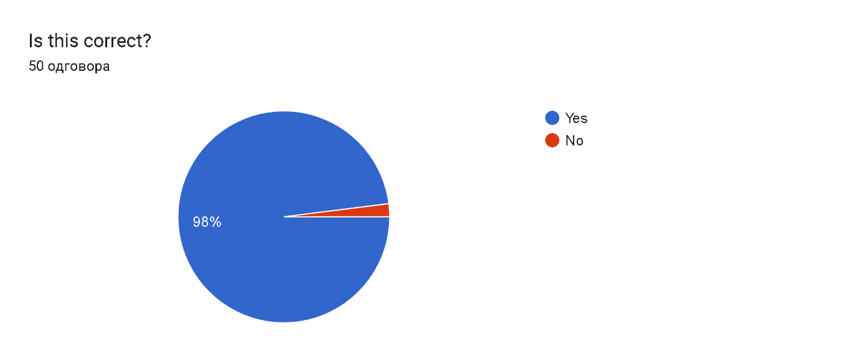

On the question „How can you protect yourself from dis/misinformation?“, 49 respondents answered correctly and 1 respondents answered incorrectly.

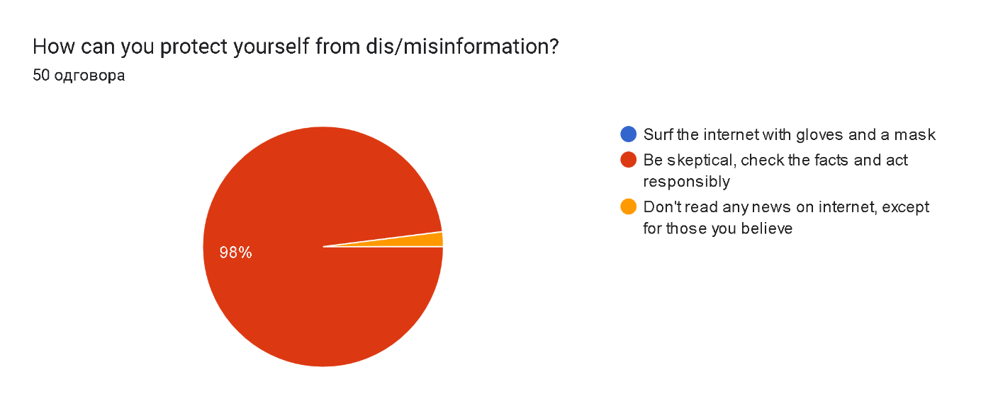

On the question „How can you protect yourself from dis/misinformation?“, 45 respondents answered correctly and 5 respondents answered incorrectly.

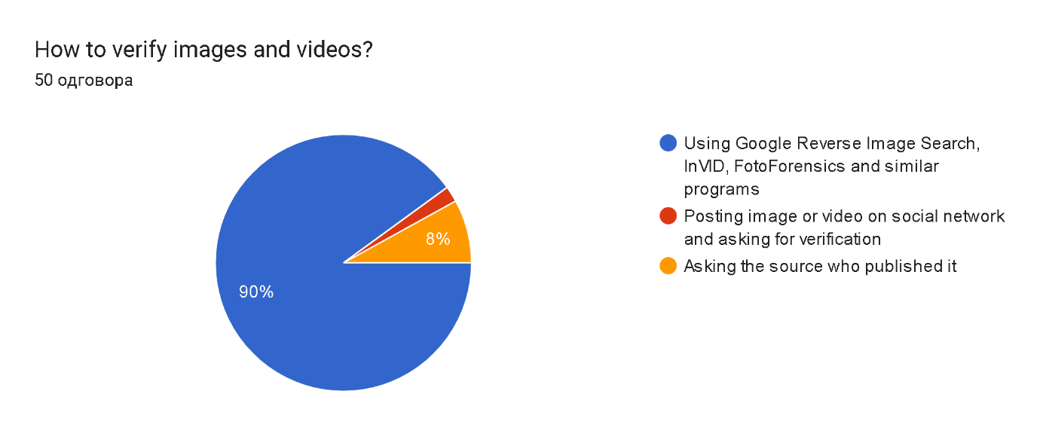

On the question „What does “OSINT“ stand for?“, 35 respondents answered correctly and 15 respondents answered incorrectly.

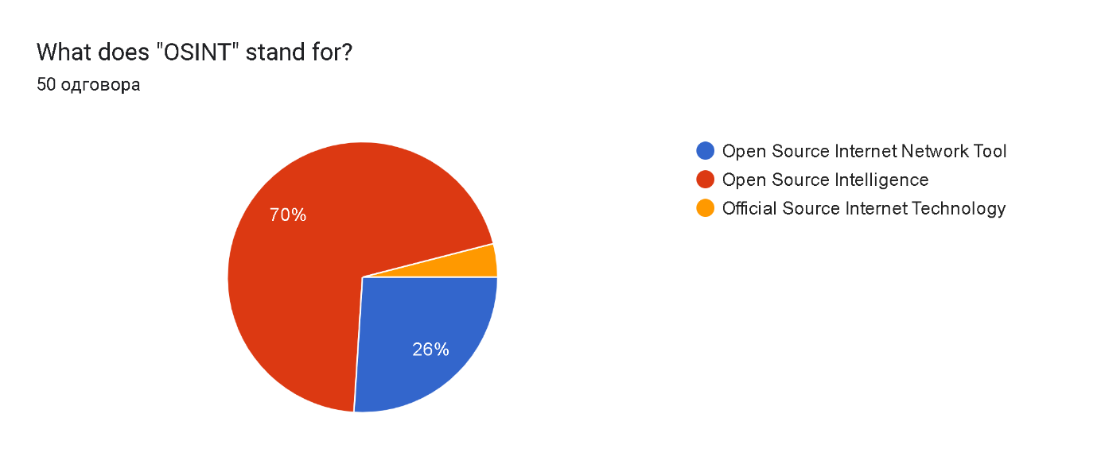

When asked to rate the importance of media literacy for the person himself, 36 respondents answered with 5 stars (maximum), 12 respondents answered with 4 stars and 2 respondents with 3.

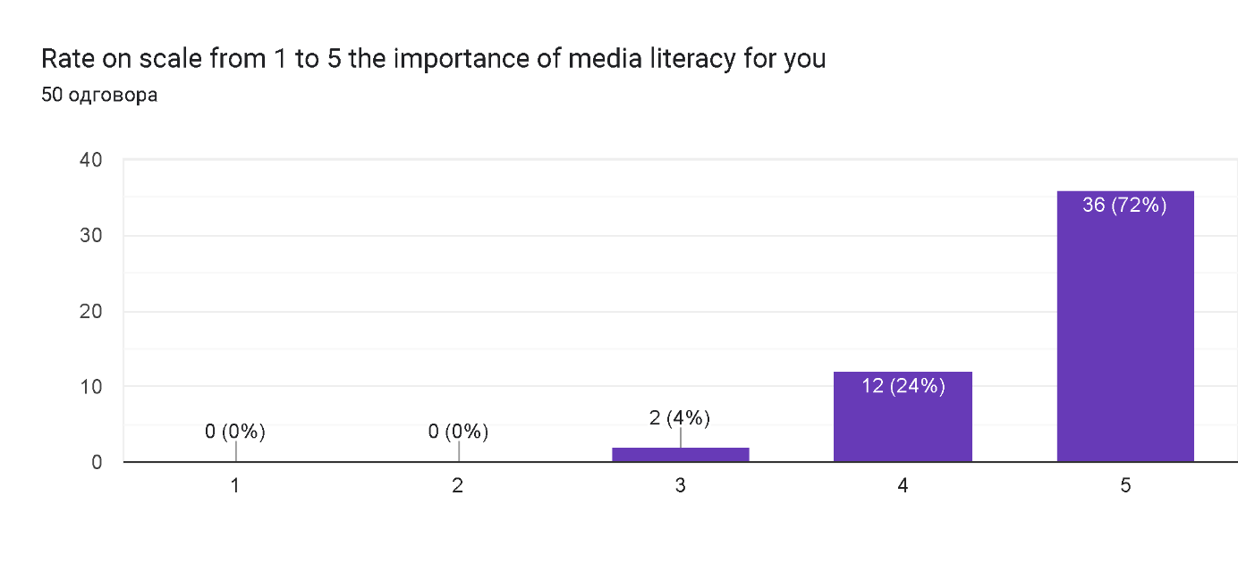

* Conclusion: Considering the overall rate of correct answers and the level of awareness of the importance of media literacy, we conclude that the campaign "Media literacy matters- Western Balkans" was successfully implemented.

**Group members**

Petar Kuveljić (RS), Uroš Aćimović (RS), Dušan Dragojević (RS), Anja Stefanović (RS), Lana Kašić (RS) and Nađa Stojanović (RM)[1].

1. RS – Republic Serbia; RM – Republic of Montenegro.